Form APR-404-00-F, Rev. I
Cryogen Order
Document Owner: Administration
Official Release Date: February 10, 2021
Approvals

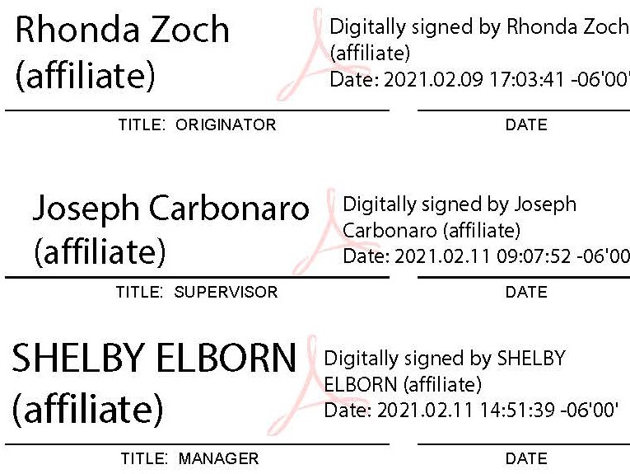

- PURPOSE
The purpose of this form is to allow Science Groups to place orders for cryogens, gases, and liquid helium for delivery to CSBF in Ft. Sumner, New Mexico or Palestine, Texas.

- EQUIPMENT REQUIREMENTS
N/A

- REFERENCES
AA-502-00-P Payload Support Process

- QUALITY RECORDS
Quality records are controlled in accordance with AS-2015-7.5-P, Control of Configuration, Documents, and Records. The specific file location for this completed document is shown below. Unless otherwise noted, the retention time will be 3 years after delivery of all items and/or completion of all services called for by the contract.

RECORD
DOCUMENT NUMBER | DOCUMENT TITLE | FILE LOCATION
APR-404-00-F | Cryogen Order Form | Individual Purchase Order file retained by Purchasing Department

REVISION CONTROL

REVISION | EFFECTIVE DATE | DESCRIPTION OF CHANGE
I | 02/10/2021 | Updated to current formatting standards; changed email address; changed phone/fax numbers

- FORM
Form begins on the following page.

SBF Science Group Gas and Cryogen Order Form

(Ft. Sumner, NM and Palestine, TX Flights ONLY)
To order cryogens, gases, and liquid helium for delivery to CSBF in Ft. Sumner, New Mexico or Palestine, Texas, complete this form and e-mail to WFF-DL-CSBF-Cryogens@mail.nasa.gov or fax to 903-723-8068, Attn: Cryogens. If faxing, please call 903-723-8042 to verify the order was received.
Important: See the CSBF Science Group Gas/Cryogen Instructions (www.csbf.nasa.gov/gas.pdf) for details about ordering and delivery schedules.

Customer Information
Payload Name: |  | Contact Name: |  | Phone:
Univ./Org. Name: |  | Contact E-mail:
Date: |  | Alternate Name: |  | Phone:
Delivery Location: | Ft. Sumner, NM Palestine, TX | Alternate E-mail:

Gas/Cryogen
Qty for 1st Delivery | Cylinder Size | Type | Specifications | Date 1st Delivery Required | Replenishment Rate |  | Notes
 |  |  |  |  | Qty | Frequency
 | LS160  NI160LLP | Liquid Nitrogen | Low pressure (22 PSI), 160L
 | LS160  NI160LMP | Liquid Nitrogen | Medium pressure (230 PSI), 160L
 | LS160  NI160LHP | Liquid Nitrogen | High pressure (350 PSI), 160L
 | LS160  AR160LMP | Liquid ARGON | Medium pressure (230 PSI), 160L
 | K Bottle | Dry Nitrogen | Standard Industrial Grade
 | K Bottle  SGUHPNI230 | Dry Nitrogen | 99.999% UHP  Grade 5 / 255 Ft³
 | T Bottle  SGUHPNI300 | Dry Nitrogen | 99.999% UHP  Grade 5 / 300 Ft³
 | K Bottle | Dry Helium | Standard Industrial Grade
 | K Bottle  HE250 | Dry Helium | 99.995% UHP  Grade 4.5 / 244 Ft³
 | K Bottle  SGUHPHE244 | Dry Helium | 99.999% UHP  Grade 5 / 244 Ft³
 | T Bottle  SGUHPHE291 | Dry Helium | 99.999% UHP  Grade 5 / 291 Ft³
 | SGRAR225M  (K bottle) | ARGON Gas | 99.9999% Res.  Grade 6 / 280 Ft³
 | SGUHPAR336  (T bottle) | ARGON Gas | 99.999% UHP  Grade 5 / 331 Ft³
 | SGICO2560M  (K bottle) | Carbon Dioxide | 99.99%, Coleman Instru. Grade / 60 lb
 | K Bottle  CA200 | Dry Air | H2O < 6ppm,  225 Ft³
 | K Bottle  SG2CA238 | Extra Dry Pre-Purified Air | H2O < 1ppm,  225 Ft³
 | Liquid Heater | Liquid Nitrogen cylinders | Air vaporizer with  hose and connector |  |  |  | Indicate size requirement:

Liquid Helium (Linde LLC)
Qty for 1st Delivery | Cylinder Size | Specifications | Date 1st Delivery Required | Replenishment Rate |  | Notes
 |  |  |  | Qty | Frequency
 | 100L Dewar | MIL-PRF-27407D
 | 500L Dewar | MIL-PTF-27407D

Comments
Enter 140 characters or less.

It is the responsibility of each science group to check all containers for correct volume and weight upon receipt.

